|  |
| --- |
| UKMARSBOT I2C Sensor Controller Datasheet |

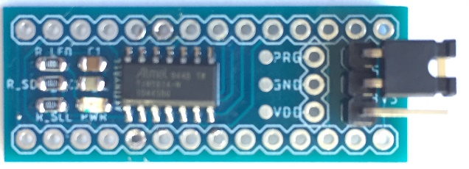

Features

* Connects directly between UKMARSBOT and existing UKMARS sensor boards to offer an I2C interface for sensors / LED indicators
* Supports UKMARS sensor boards that contain up to:
  + 5 x Analogue Sensor Inputs
  + 1 x Common Transmitter Output
  + 2 x Indicator LEDs
* Collects sensor data periodically, with configurable:
  + Ambient light removal
  + Sensor transmitter pulse length
  + ADC Resolution (8-bit / 10-bit)
  + Sensor selection – disable unused sensors for increased speed
* Threshold Comparison:
  + Compares each sensor value against a configurable threshold value to return Sensor State
* Configurable Interrupt Source (may be polled):
  + Rising and/or Falling Sensor state change
    - Individually Settable for each Sensor
  + Sensor board specific interrupt
* Configurable Indicator LED control:
  + Master Control (over I2C)
  + Sample Frequency output
  + Slow/Fast Blink
  + Board specific indication
* Selectable Operating Voltage
  + 3.3V or 5V
* Sensor board specific features and Interrupts
  + Selectable over I2C

Functional Block Diagram of Application

Below is a diagram showing the application in which the ISC is intended to be used.

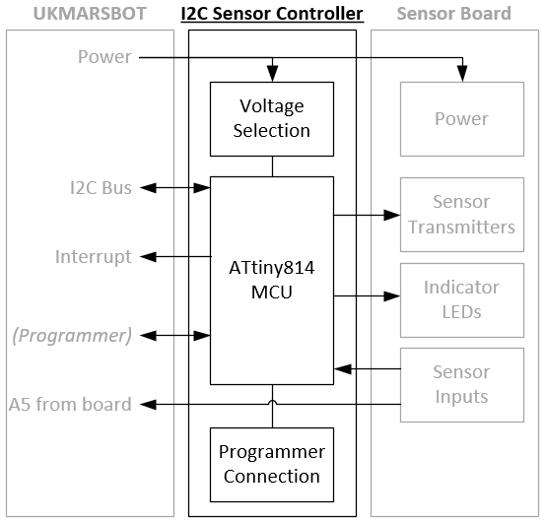

Table of Contents

1.0 PIN DESCRIPTIONS 3

2.0 DEVICE OVERVIEW 3

3.0 POWER-ON SEQUENCE 4

4.0 SERIAL INTERFACE (I2C) 4

5.0 PERFORMANCE 5

6.0 ISC REGISTER SUMMARY 6

7.0 ISC REGISTER DESCRIPTIONS 7

8.0 LINE SENSOR REGISTER SUMMARY 18

9.0 SCHEMATIC 23

10.0 FIRMWARE REVISION HISTORY 24

11.0 ADDING A NEW REGISTER 25

12.0 COMMISSIONING NOTES 27

13.0 APPLICATION NOTES 28

**Nomenclature**

Below are definitions of how the following are used in the context of this datasheet:

ISC I2C Sensor Controller

MCU Microcontroller connected to the ‘Arduino Nano’ Style headers on the UKMARSBOT

# PIN DESCRIPTIONS

The pin functions and recommended MCU pin configuration are listed in Table 1.

Table 1 - PINOUT DESCRIPTION

|  |  |  |
| --- | --- | --- |
| **UKMARSBOT Pin Name** | **UKMARSBOT Pin Mode** | **Function** |
| 5V | Power | Provides 5V to equivalent Sensor Board pin |
| GND | Power | Provides Ground to equivalent Sensor Board pin |
| A5 | I2C SCL | I2C Serial Clock (with optional pullup resistor attached) |
| A4 | I2C SDA | I2C Serial Data (with optional pullup resistor attached) |
| A3 | UPDI | Used only to flash program to the ISC when using Arduino as UPDI programmer |
| A2 | Analog Input | Directly connected to A5 pin on Sensor Board |
| A1 | Digital Input | Interrupt - configurable |
| *A0* | *NC* | *May use elsewhere on UKMARSBOT* |
| *D11* | *NC* | *May use elsewhere on UKMARSBOT* |
| *D12* | *NC* | *May use elsewhere on UKMARSBOT* |
| *D6* | *NC* | *May use elsewhere on UKMARSBOT* |
| GND | Power | Ground |
| 5V | Power* | Provides 5V to equivalent Sensor Board pin |
| 3V3 | Power* | Provides 3.3V to equivalent Sensor Board pin |

* The Voltage Selection jumper selects between these signals to supply power to the ISC, this defines the logic levels and must match that of the MCU.

# DEVICE OVERVIEW

The I2C Sensor Controller (ISC) consists of a programmed ATtiny814 microcontroller on a PCB with hardware pinouts to connect directly between the UKMARSBOT and sensor board. The device continuously samples the sensors and performs threshold comparison on these to return sensor states and may be configured to interrupt on such state changes. Sensor values and configuration are stored in registers which are accessible to the UKMARSBOT MCU over an I2C bus.

**Sensor Configuration**

Sensors are configured in the SENS#SETUP register. To read the sensor, it must be Enabled. If ambient light removal is required, TX_EN must be set. The POLARITY register represents whether the sensor value increases with more reflected light or not. Finally, Rising and Falling interrupts may be configured by setting the corresponding bits.

**Sensor State**

Once a sensor is configured, the most recent value may be read directly from the SENS#VAL register. Furthermore, each enabled sensor is dynamically compared to the value contained in the associated threshold register (SENS#THRSH). If SENS#VAL exceeds this, the corresponding bit in SENSSTATE register is set. Hence the state of all sensors can be read as a single register for speed and convenience.

**Interrupts**

The interrupt pin indicates that an interrupt condition has occurred and will remain HIGH while INTERRUPTFLAGS ≠ 0. The interrupt conditions are configured in INTERRUPTCTRL register.

**LED Indication**

The built-in LED indicators on all UKMARSBOT sensor boards may be controlled by writing to the LEDCTRL register. LLED and RLED bits may be written to directly, however, the ISC offers internal control of the LEDs with the INDICATION_MODE value. When written to, the LEDs will be controlled independently of the UKMARSBOT MCU. They can be set to flash at different rates, indicate sensor state and more.

# POWER-ON SEQUENCE

It is recommended that the ISC is connected to the UKMARSBOT and Sensor board prior to the supply of power. Once power is supplied, the ISC must be configured. Furthermore, any subsequent loss of power requires the configuration to be set again.

The following flow diagrams illustrate the relationship between MCU and ISC on Power-up or MCU reset.

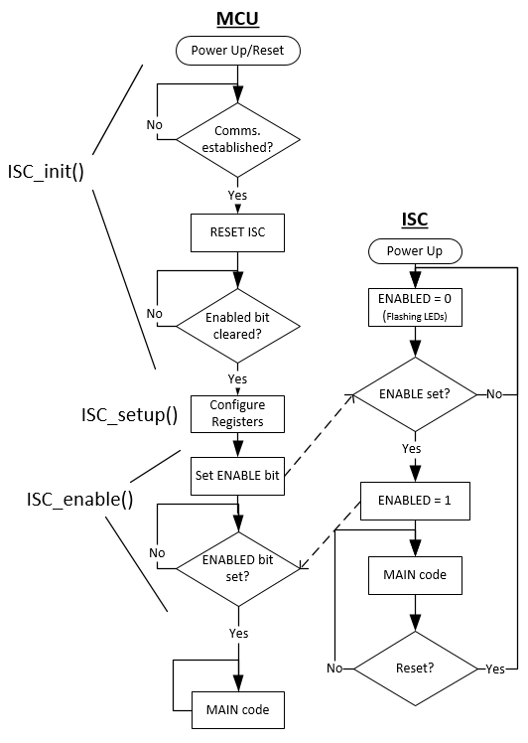

1. When first connected to power, the ENABLED bit is LOW, indicating that registers must be configured by the MCU.
2. Once all registers have been configured, the MCU sets the ENABLE bit in the ISC.
3. The MCU waits for the ENABLED bit to be set, confirming that ISC setup is complete.
4. MCU enters the main code.

It is recommended that the MCU always issue a RESET command after start-up in the event that the power has remained on, but the MCU has been reset. This forces the ISC back into a power-up state.

# SERIAL INTERFACE (I2C)

The ISC contains individual 8-bit registers (some of which form pairs) that can be addressed through the I2CSerial Interface at address 0x50 (7-bit). An overview of these may be found in Section 6.0 ISC REGISTER SUMMARY. With further details located in Section 7.0 ISC REGISTER DESCRIPTION.

The ISC automatically increments the address pointer after sending each byte during the data transfer. This may be utilised when reading consecutive registers such as sensor values. Simply write the first register address, then read, with repeated starts to retrieve consecutive bytes. The address pointer automatically rolls over to address 0x00 after accessing the last register.

The I2C protocol requires pull-up resistors on the SCL and SDA lines, these are fitted to the ISC by default. If they are already fitted elsewhere on the bus, eg. MCU or other I2C peripheral, the resistors must be de-soldered from the ISC.

The ISC has been tested at 400 kHz clock speed with no adverse effects.

Refer to **Section 26. TWI – Two Wire Interface** of the ATTiny814 Manual for detailed requirements:

<http://ww1.microchip.com/downloads/en/DeviceDoc/40001912A.pdf>

Accessing 16-bit Registers

The I2C bus permits the transmission of data packets no longer than 8 bits in length. Registers permitted to contain a value exceeding 8-bits must be byte-accessed using two read or write operations.

For a write operation, the MSB of the 2-byte register pair must be written before the corresponding LSB. The MSB is stored in a temporary register until the LSB of the 2-byte register pair is written, the temporary register is then combined with this, and the 2-byte value is obtained and used by the ISC.

For a read operation, it is insignificant which of the two bytes in a 2-byte register pair is accessed first. When the LSB or MSB of a 2-byte register pair is read, the corresponding byte is copied into a temporary register in the same instruction as the initial read. When the corresponding byte is read, it is then read from the temporary register. This ensures that the low and high bytes of 16-bit registers are always accessed simultaneously when reading or writing the register.

# PERFORMANCE

The following tests have been conducted to provide an indication of the performance that is to be expected from the ISC. All were performed with an Arduino Nano V3.0 Clone fitted onto a standard UKMARS Chassis with the ISC located between the UKMARSBOT and Basic Line Sensor board, operating at 5V.

The following remained constant for all experiments:

* All registers contain their default values other than what is detailed below.
* LED control was set to FREQOUT and a PicoScope2204 was connected to measure the loop frequency

## Read 1 Sensor RAW value

Sensor 1 enabled.

## Read 1 Sensor with Tx LED at ≥20µs

## Read 6 Sensor’s RAW values

## Read 6 Sensors with Tx LED at ≥20µs

1 Sensor active with threshold comparison. 664us

Value / Counts per second = time (approx. 0.52ms for all 6 sensors).

# ISC REGISTER SUMMARY

|  |  |  |  |  |  |  |  |  |  |  |
| --- | --- | --- | --- | --- | --- | --- | --- | --- | --- | --- |
| **OFFSET** | **Name** | **Bit Pos** |  |  |  |  |  |  |  |  |
| 0 (0x00) | FIRMVER | 7:0 | FIRMWARE_VERSION | | | | | | | |
| 1 (0x01) | CONTROL | 7:0 | ENABLED |  |  | BOARD TYPE | | | RESET | ENABLE |
| 2 (0x02) | INTERRUPT CTRL | 7:0 | BRDINTEN |  |  | SENS4 INTEN | SENS3 INTEN | SENS2 INTEN | SENS1 INTEN | SENS0 INTEN |
| 3 (0x03) | INTERRUPT FLAGS | 7:0 | BRDINT |  |  | SENS4 INT | SENS3 INT | SENS2 INT | SENS1 INT | SENS0 INT |
| 4 (0x04) | SENSSTATE | 7:0 |  |  |  | SENS4 STATE | SENS3 STATE | SENS2 STATE | SENS1 STATE | SENS0 STATE |
| 5 (0x05) | LEDCTRL | 7:0 | LLED | RLED |  |  |  | INDICATION_MODE | | |
| 6 (0x06) | PULSEDUR | 7:0 | PULSE_DURATION (µs) | | | | | | | |
| 7 (0x07) | SENS0SETUP | 7:0 | R_INTENB | F_INTENB | POLARITY |  |  | TX_EN | RESOL | ENB |
| 8 (0x08) | SENS1SETUP | 7:0 | R_INTENB | F_INTENB | POLARITY |  |  | TX_EN | RESOL | ENB |
| 9 (0x09) | SENS2SETUP | 7:0 | R_INTENB | F_INTENB | POLARITY |  |  | TX_EN | RESOL | ENB |
| 10 (0x0A) | SENS3SETUP | 7:0 | R_INTENB | F_INTENB | POLARITY |  |  | TX_EN | RESOL | ENB |
| 11 (0x0B) | SENS4SETUP | 7:0 | R_INTENB | F_INTENB | POLARITY |  |  | TX_EN | RESOL | ENB |
| 12 (0x0C) | Reserved | 7:0 |  |  |  |  |  |  |  |  |
| 13 (0x0D) | SENS0VAL | 15:8 | MSByte of SENS0VAL | | | | | | | |
| 14 (0x0E) | 7:0 | LSByte of SENS0VAL | | | | | | | |
| 15 (0x0F) | SENS1VAL | 15:8 | MSByte of SENS1VAL | | | | | | | |
| 16 (0x10) | 7:0 | LSByte of SENS1VAL | | | | | | | |
| 17 (0x11) | SENS2VAL | 15:8 | MSByte of SENS2VAL | | | | | | | |
| 18 (0x12) | 7:0 | LSByte of SENS2VAL | | | | | | | |
| 19 (0x13) | SENS3VAL | 15:8 | MSByte of SENS3VAL | | | | | | | |
| 20 (0x14) | 7:0 | LSByte of SENS3VAL | | | | | | | |
| 21 (0x15) | SENS4VAL | 15:8 | MSByte of SENS4VAL | | | | | | | |
| 22 (0x16) | 7:0 | LSByte of SENS4VAL | | | | | | | |
| 23 (0x17) | Reserved | 15:8 |  | | | | | | | |
| 24 (0x18) | 7:0 |  | | | | | | | |
| 25 (0x19) | SENS0THRSH | 15:8 | MSByte of SENS0THRSH | | | | | | | |
| 26 (0x1A) | 7:0 | LSByte of SENS0THRSH | | | | | | | |
| 27 (0x1B) | SENS1THRSH | 15:8 | MSByte of SENS1THRSH | | | | | | | |
| 28 (0x1C) | 7:0 | LSByte of SENS1THRSH | | | | | | | |
| 29 (0x1D) | SENS2THRSH | 15:8 | MSByte of SENS2THRSH | | | | | | | |
| 30 (0x1E) | 7:0 | LSByte of SENS2THRSH | | | | | | | |
| 31 (0x1F) | SENS3THRSH | 15:8 | MSByte of SENS3THRSH | | | | | | | |
| 32 (0x20) | 7:0 | LSByte of SENS3THRSH | | | | | | | |
| 33 (0x21) | SENS4THRSH | 15:8 | MSByte of SENS4THRSH | | | | | | | |
| 34 (0x22) | 7:0 | LSByte of SENS4THRSH | | | | | | | |
| 35 (0x23) | Reserved | 15:8 |  | | | | | | | |
| 36 (0x24) | 7:0 |  | | | | | | | |
| 37 (0x25) | SCANTIME | 15:8 | MSByte of SCANTIME | | | | | | | |
| 38 (0x26) | 7:0 | LSByte of SCANTIME | | | | | | | |
| 39 (0x27) | Board Specific Registers – More details in specific board section. | | | | | | | | | |
| … |

# ISC REGISTER DESCRIPTIONS

## Firmware Version

* Name: FIRMVER
* Offset: 0x00
* Reset: 0x##

|  |  |  |  |  |  |  |  |  |
| --- | --- | --- | --- | --- | --- | --- | --- | --- |
| Address | 7 | 6 | 5 | 4 | 3 | 2 | 1 | 0 |
| 0x00 | FIRMWARE_VERSION[7:0] | | | | | | | |
| Access | R | | | | | | | |
| Reset | ## | | | | | | | |

Bits 7:0 – FIRMWARE_VERSION[7:0]

Firmware version installed on the ISC. See Section *8.4*

## Control

* Name: CONTROL
* Offset: 0x01
* Reset: 0x00

|  |  |  |  |  |  |  |  |  |
| --- | --- | --- | --- | --- | --- | --- | --- | --- |
| Address | 7 | 6 | 5 | 4 | 3 | 2 | 1 | 0 |
| 0x01 | ENABLED |  |  | BOARD_TYPE[2:0] | | | RESET | ENABLE |
| Access | R |  |  | R/W | | | W | W |
| Reset | 0 |  |  | 0 | | | 0 | 0 |

Bit 7 – ENABLED

Status of board operation:

Set HIGH when the ENABLE is HIGH

Set LOW when RESET is HIGH

Bits 4:2 – BOARD_TYPE[2:0]

Defines the board that is connected to the ISC:

|  |  |
| --- | --- |
| **Value** | **Board** |
| 0 (0x00) | Undefined |
| 1 (0x01) | UKMARS Basic Line Sensor |
| 2 (0x02) | UKMARS Basic Wall Sensor |
| 3 (0x03) | S. Pithouse Line Sensor |

Bit 1 – RESET

Set HIGH to reset the sensor board. Clears to a 0 immediately. This sets ENABLED LOW.

Bit 0 – ENABLE

Set HIGH when to start the main sequence. Clears to a 0 immediately. This sets ENABLED HIGH.

## Interrupt Control

* Name: INTERRUPTCTRL
* Offset: 0x02
* Reset: 0x00

|  |  |  |  |  |  |  |  |  |
| --- | --- | --- | --- | --- | --- | --- | --- | --- |
| Address | 7 | 6 | 5 | 4 | 3 | 2 | 1 | 0 |
| 0x02 | BRD INTEN |  |  | SENS4 INTEN | SENS3 INTEN | SENS2 INTEN | SENS1 INTEN | SENS0 INTEN |
| Access | R/W |  |  | R/W | R/W | R/W | R/W | R/W |
| Reset | 0 |  |  | 0 | 0 | 0 | 0 | 0 |

Bit 7 – BRDINTEN

Set HIGH to enable interrupts from *BRDINTFLAG* register.

Bit 4-0 – SENS4INTEN – SENS0INTEN

Set HIGH to enable an interrupt on the corresponding sensor changing state.

NOTE that the interrupt bit must be set in *SENS#SETUP* to enable the specific sensor to trigger an interrupt.

## Interrupt Flags

* Name: INTERRUPTFLAGS
* Offset: 0x03
* Reset: 0x00

|  |  |  |  |  |  |  |  |  |
| --- | --- | --- | --- | --- | --- | --- | --- | --- |
| Address | 7 | 6 | 5 | 4 | 3 | 2 | 1 | 0 |
| 0x03 | BRD INT |  |  | SENS4 INT | SENS3 INT | SENS2 INT | SENS1 INT | SENS0 INT |
| Access | R |  |  | R/W | R/W | R/W | R/W | R/W |
| Reset | 0 |  |  | 0 | 0 | 0 | 0 | 0 |

Bit 7 – BOARD

HIGH when a bit is set in *BRDINTFLAGS.*

LOW when all bits in *BRDINTFLAGS* are LOW.

See *BRDINTFLAGS* for details on how to clear interrupt bits.

Bit 4-0 – SENS#STATE

Set HIGH internally by the ISC if the following conditions are met:

|  |  |  |
| --- | --- | --- |
| SENS#INTEN set HIGH in INTERRUPT_CTRL | | |
| R_INT_ENB set HIGH in SENS#SETUP | OR | F_INT_ENB set HIGH in SENS#SETUP |
| SENS#VAL has risen above SENS#THRSH | SENS#VAL has fallen below SENS#THRSH |

Must be reset externally. To reset, write a 1 to the corresponding bit location.

## Sensor State

* Name: SENSSTATE
* Offset: 0x04
* Reset: 0x00

|  |  |  |  |  |  |  |  |  |
| --- | --- | --- | --- | --- | --- | --- | --- | --- |
| Address | 7 | 6 | 5 | 4 | 3 | 2 | 1 | 0 |
| 0x04 |  |  |  | SENS4STATE | SENS3STATE | SENS2STATE | SENS1STATE | SENS0STATE |
| Access |  |  |  | R | R | R | R | R |
| Reset |  |  |  | 0 | 0 | 0 | 0 | 0 |

Bit 4-0 – SENS#STATE

Result of most recent comparison between *SENS#VAL* and *SENS#THRSH* registers.

HIGH if SENS#VAL > SENS#THRSH.

If the corresponding interrupt flag is on, the state remains frozen until the interrupt is cleared. This allows the state to be interrogated to determine the direction of the interrupt.

## Indicator LED Control

* Name: LEDCTRL
* Offset: 0x05
* Reset: 0x00

|  |  |  |  |  |  |  |  |  |
| --- | --- | --- | --- | --- | --- | --- | --- | --- |
| Address | 7 | 6 | 5 | 4 | 3 | 2 | 1 | 0 |
| 0x05 | LLED | RLED |  |  |  | INDICATION_MODE[2:0] | | |
| Access | R/W | R/W |  |  |  | R/W | | |
| Reset | 0 | 0 |  |  |  | 0x00 | | |

Bit 7 - LLED

Returns current state of the Left Indicator LED. Where 0: OFF and 1: ON.

The Left Indicator LED state may be set by writing a 0 or 1 to this bit when *INDICATION_MODE* is set to MASTER CONTROL.

Bit 6 - RLED

Returns current state of the Right Indicator LED. Where 0: OFF and 1: ON.

The Right Indicator LED state may be set by writing a 0 or 1 to this bit when *INDICATION_MODE* is set to MASTER CONTROL.

Bits 2:0 – INDICATION_MODE[2:0]

|  |  |  |
| --- | --- | --- |
| **Value** | **Description** | |
| 0 | MASTER CONTROL | Indicator LEDs are controlled by corresponding bits *LLED* and *RLED* |
| 1 | FREQOUT | Toggles LED state each sample cycle – this can be used to determine the sample rate |
| 2 | OFF | Force both indicator LEDs OFF |
| 3 | BRDCONTROL | Indicator LEDs reflect state specific to the attached Sensor board. See BRDCONFIG register for details |
| 4 | FASTBLINK | Indicator LEDs flash quickly until INDICATION MODE value is changed |
| 5 | SLOWBLINK | Indicator LEDs flash slowly until INDICATION MODE value is changed |

## Pulse Duration

* Name: PULSEDUR
* Offset: 0x06
* Reset: 0x0A

|  |  |  |  |  |  |  |  |  |
| --- | --- | --- | --- | --- | --- | --- | --- | --- |
| Address | 7 | 6 | 5 | 4 | 3 | 2 | 1 | 0 |
| 0x06 | PULSE_DURATION[7:0] | | | | | | | |
| Access | R/W | | | | | | | |
| Reset | 0x0A | | | | | | | |

Bits 7:0 – PULSE_DURATION[7:0]

Minimum time (in µs) that emitter is on before an ADC is performed. This is only used when TXEN bit is TRUE in corresponding SENS#SETUP.

## Sensor Setup

* Name: SENS#SETUP
* Offset: 0x07 –> 0x0B
* Reset: 0x00

|  |  |  |  |  |  |  |  |  |
| --- | --- | --- | --- | --- | --- | --- | --- | --- |
| Address | 7 | 6 | 5 | 4 | 3 | 2 | 1 | 0 |
| 0x07 | R_INTENB | F_INTENB | POLARITY |  |  | TX_EN | RESOL | ENB |
| Access | R/W | R/W | R/W |  |  | R/W | R/W | R/W |
| Reset | 0 | 0 | 0 |  |  | 0 | 0 | 0 |

Bit 7 – R_INTENB

Enables ability for Sensor to trigger an interrupt on a rising edge change – note that sensor state interrupt must be enabled in *INTCTRL* Register.

Bit 6 - F_INTENB

Enables ability for sensor to trigger an interrupt on a falling edge change – note that sensor state interrupt must be enabled in *INTCTRL* Register.

Bit 5 - POLARITY

Not used when BOARD TYPE is defined. POLARITY is used to inform the ISC whether a low Analog Read value represents white or black.

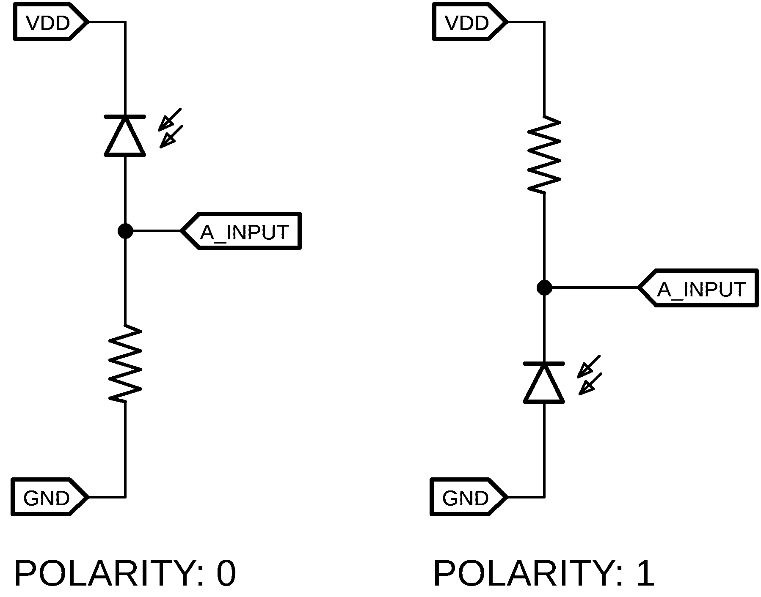 ??? or ??? 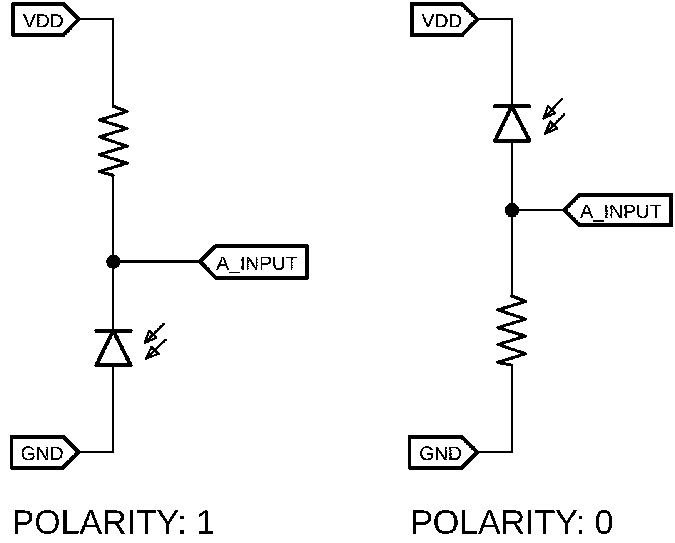

Bit 2 – TX_EN

0: Disables the use of the Emitter LED when sampling the sensor. The selected sensor is sampled with the LED turned off and the result is returned in *SENS#VAL* Register.

1: Enables the use of the Sensor Transmitter. The sensors will be sampled, then the Emitter turned on for a duration (in units of µs) set by *PULSEDUR* register before being sampled again. The difference between these is returned in *SENS#VAL* Register.

Bit 1 – RESOLUTION

0: *SENS#VAL* Register pair contains 10-bit result from sensor

1: *SENS#VAL* Register pair contains 8-bit result from sensor. The ADC sample resolution remains 10-bit, it is converted to 8-bit when stored in the register.

Bit 0 - ENB

When TRUE, the sensor will be sampled each scan, set this to FALSE if sensor is not being used to reduce time between consecutive samples

## Sensor Value

* Name: SENS#VAL
* Offset: 0x0D -> 0x16
* Reset: 0x0000

|  |  |  |  |  |  |  |  |  |
| --- | --- | --- | --- | --- | --- | --- | --- | --- |
| Address | 7 | 6 | 5 | 4 | 3 | 2 | 1 | 0 |
| 0x0D | MSByte of SENS0VAL | | | | | | | |
| 0x0E | LSByte of SENS0VAL | | | | | | | |
| 0x0F – 0x16 | MSByte/LSByte of SENS1-4VAL | | | | | | | |
| Access | R | | | | | | | |
| Reset | 0x00 | | | | | | | |

Addresses 0x0D to 0x16 allow the most recent sensor value to be read for each sensor, starting with Sensor 0. Values are up to 10-bits long, hence are organised across two registers.

When the MSB register is read, the corresponding I2C register becomes ‘frozen’ so that the LSB register refers to the same value. This prevents the value getting updated between MSB and LSB reads.

After the LSB register has been read, the value becomes ‘unfrozen’, allowing it to update before the next read.

## Sensor Threshold

* Name: SENS#THRSH
* Offset: 0x19 -> 0x22
* Reset: 0x0000

|  |  |  |  |  |  |  |  |  |
| --- | --- | --- | --- | --- | --- | --- | --- | --- |
| Address | 7 | 6 | 5 | 4 | 3 | 2 | 1 | 0 |
| 0x19 | MSByte of SENS0THRSH | | | | | | | |
| 0x1A | LSByte of SENS0THRSH | | | | | | | |
| 0x1B -0x22 | MSByte/LSByte of SENS1-4THRSH | | | | | | | |
| Access | R/W | | | | | | | |
| Reset | 0x0000 | | | | | | | |

Addresses 0x19 to 0x22 contain sensor threshold values associated with each sensor, starting with Sensor 0. Values may be up to 10-bits long, hence are organised across two registers.

Bits 15:0 – SENS0THRSH[15:0]

Threshold value which sensor value is compared against to determine the sensor state.

## Scan Time

* Name: SCANTIME
* Offset: 0x25 -> 0x26
* Reset: 0x0000

|  |  |  |  |  |  |  |  |  |
| --- | --- | --- | --- | --- | --- | --- | --- | --- |
| Address | 7 | 6 | 5 | 4 | 3 | 2 | 1 | 0 |
| 0x25 | MSByte of SCANTIME[15:8] | | | | | | | |
| 0x26 | LSByte of SCANTIME[7:0] | | | | | | | |
| Access | R | | | | | | | |
| Reset | 0x0000 | | | | | | | |

Bits 15:0 - SCANTIME[15:0]

Time (in µs) taken for the last complete cycle. May be used to monitor the Sensor refresh rate.

The value (0 µs to 65,535 µs) has a resolution of 1.2µs.

Note that in the event that a Timer overflow occurs, a value of 0xFFFF will be stored.

# LINE SENSOR REGISTER SUMMARY

|  |  |  |  |  |  |  |  |  |  |  |
| --- | --- | --- | --- | --- | --- | --- | --- | --- | --- | --- |
| **OFFSET** | **Name** | **Bit Pos** |  |  |  |  |  |  |  |  |
| 39 (0x27) | BRDCONFIG | 7:0 | CALIB COMPL |  |  |  |  | BRD_INDICATION_MODE | | |
| 40 (0x28) | BRDINTCTRL | 7:0 |  |  |  |  |  |  | CROSS OVERINTEN | LOST LINEINTEN |
| 41 (0x29) | BRDINTFLAGS | 7:0 |  |  |  |  |  |  | CROSS OVERINT | LOST LINEINT |
| 42 (0x2A) | LINEERROR | 15:8 | MSByte of Line Error | | | | | | | |
| 43 (0x2B) | 7:0 | LSByte of Line Error | | | | | | | |

## Board Configuration

* Name: BRDCONFIG
* Offset: 0x27
* Reset: 0x00

|  |  |  |  |  |  |  |  |  |
| --- | --- | --- | --- | --- | --- | --- | --- | --- |
| Address | 7 | 6 | 5 | 4 | 3 | 2 | 1 | 0 |
| 0x27 | CALIB COMPL |  |  |  |  | BRD_INDICATION_MODE | | |
| Access | R |  |  |  |  | R/W | | |
| Reset | 0 |  |  |  |  | 0 | | |

Bit 7 – CALIBCOMPL

Gets set to TRUE once the initial line sensor calibration has completed

Bits 2:0 - BRD_INDICATION_MODE

When LEDCTRL INDICATION_MODE value is set for BRDCONTROL, BRD_INDICATION_MODE value controls the status of the LEDs.

|  |  |  |
| --- | --- | --- |
| **Value** | **Description** | |
| 0 | SIDE | Indicator LEDs indicate the side of the line that the robot is on |
| 1 | MARKER Threshold | Indicator LEDs indicate the live state of the track marker sensors |
| 2 | L/R threshold | Left LED ON when left sensor above threshold, and right LED on when right sensor above threshold |

## Board Interrupt Control

* Name: BRDINTCTRL
* Offset: 0x28
* Reset: 0x00

|  |  |  |  |  |  |  |  |  |
| --- | --- | --- | --- | --- | --- | --- | --- | --- |
| Address | 7 | 6 | 5 | 4 | 3 | 2 | 1 | 0 |
| 0x28 |  |  |  |  |  |  | CROSS OVRINTEN | LOST LINEINTEN |
| Access |  |  |  |  |  |  | R/W | R/W |
| Reset | 0x00 | | | | | | | |

Bit 1 – CROSSOVERINTEN

Set HIGH to enable interrupts from *CROSSOVERINT* bit.

Bit 0 – LOSTLINEINTEN

Set HIGH to enable interrupts from *LOSTLINEINT* bit.

## Board Interrupt Flags

* Name: BRDINTFLAGS
* Offset: 0x29
* Reset: 0x00

|  |  |  |  |  |  |  |  |  |
| --- | --- | --- | --- | --- | --- | --- | --- | --- |
| Address | 7 | 6 | 5 | 4 | 3 | 2 | 1 | 0 |
| 0x29 |  |  |  |  |  |  | CROSS OVRINT | LOST LINEINT |
| Access |  |  |  |  |  |  | R/W | R/W |
| Reset |  |  |  |  |  |  | 0 | 0 |

Bit 2 – CROSSOVRINT

Set to TRUE when a crossover is detected – may be used to ignore marker sensors. Reset by writing a 1 to this location

Bit 0 – LOSTLINEINT

Set TRUE when the sensor cannot detect a line. Reset by writing a 1 to this location

## Line Error

* Name: Line Error
* Offset: 0x2A -> 0x2B
* Reset: 0x0000

|  |  |  |  |  |  |  |  |  |
| --- | --- | --- | --- | --- | --- | --- | --- | --- |
| Address | 7 | 6 | 5 | 4 | 3 | 2 | 1 | 0 |
| 0x2A | MSByte of LINEERROR[15:8] | | | | | | | |
| 0x2B | LSByte of LINEERROR[7:0] | | | | | | | |
| Access | R | | | | | | | |
| Reset | 0x0000 | | | | | | | |

Bits 15:0 – LINEERROR

Distance from line. Note that a value of 512 represents no error (centred on line).

The LINEERROR[15:8] and LINEERROR[7:0] register pair represents the 16-bit value, LINEERROR. The high byte [15:8] is accessible at the original offset. The low byte [7:0] can be accessed at offset + 0x01. For more details on reading and writing 16-bit registers, refer to Accessing 16-bit Registers.

# SCHEMATIC

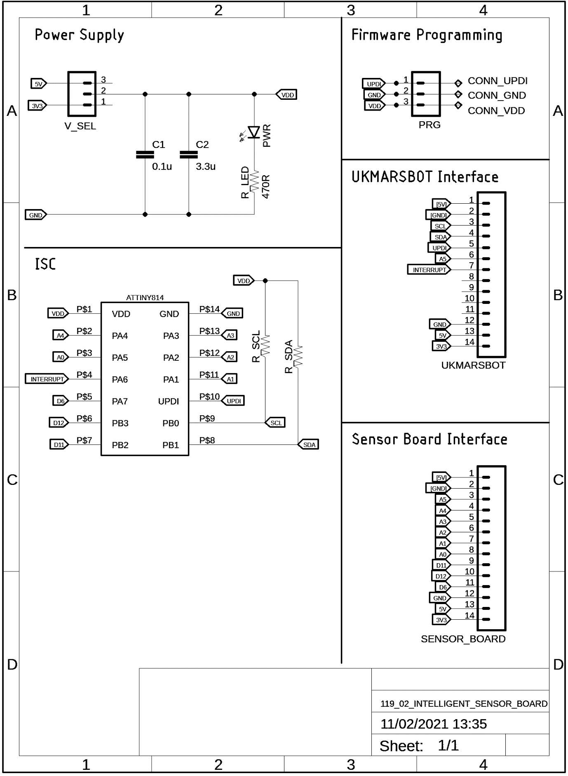

# DIMENSIONS

The below diagram details the outer board dimension and the distance between header rows. The header pitch is a standard 0.1”.

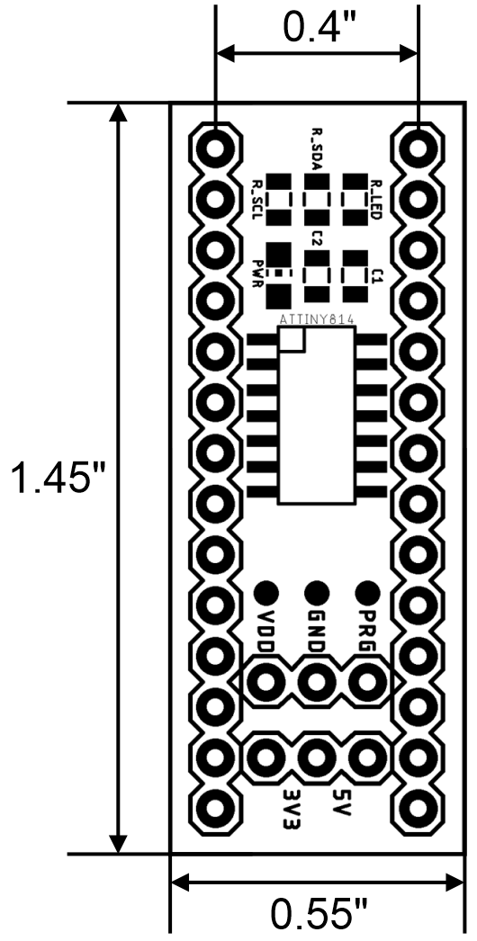

# FIRMWARE REVISION HISTORY

Firmware revisions are detailed in Table 2.

Table 2 - Revision History

|  |  |  |
| --- | --- | --- |
| **Version** | **Date** | **Details** |
| 1 | 19/12/2020 | Release Version |
| 2 | 20/01/2021 | Added ENABLED Register – ENABLE is now to be a strobe |
| 3 | 22/01/2021 | Shuffled registers around |
| 4 | 25/01/2021 | Using RTC interrupt for LED flashing and Timer A for scanTime |
| 5 | 26/01/2021 | Reset interrupt output in receive function, set at end of loop |
| 6 | 01/02/2021 | Added blink modes in LEDCTRL and modified I2C sendData to update reg[] for all 2-byte values |
| 7 | 11/02/2021 | Tidied up manual on plane – removed notes etc to notes document |